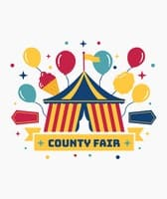
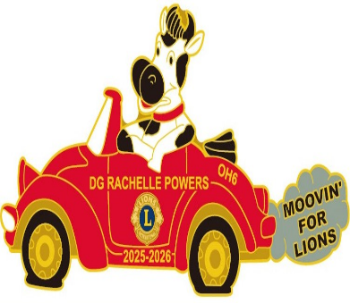
OH 6 Cabinet Appreciation
And
“Moovin for Lions”
County Fair and Mexican Dinner
District Governor Rachelle Powers and Lion Josh
Invite OH 6 Cabinet Members and a Guest
To attend
The OH 6 2026 Cabinet Appreciation Dinner
Friday evening, April 24, 2026 at 6:30pm
Embassy Suites
4554 Lake Forest Drive
Blue Ash, OH 45242
Reservations needed. Please respond with a completed Convention Registration form to PCC Lydia Houser, (937) 609-6594, no later than April 2nd.
DO NOT PAY FOR THIS MEAL IN YOUR CONVENTION REGISTRATION
Email is LMHYOYO@aol.com
Cabinet Members—we are looking forward to seeing you Friday, April 24th for the 2025-2026 Cabinet Appreciation Dinner and Lions Night. We will be having dinner and an evening of enjoyment with fun entertainment focused on the County Fair theme. Dress is lions casual or dress up in your favorite County Fair clothes. Who knows, you might win the costume contest! The dinner will start at 6:30pm, we will have entertainment and afterwards Governor Rachelle will be sharing her appreciation to all the Cabinet Members and introducing International Director Bert Nelson and Lion Pam.
Cabinet Members—Payment for your full convention registration is $71.00 (Saturday lunch/dinner). Friday night is NO COST for Cabinet Member and Guest. Please annotate this on your registration.

