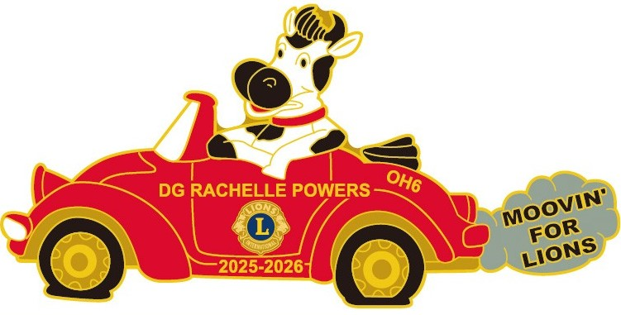

Application for Advertisement Space in the 2026 District 13 OH6 Convention Commemorative Program
Please reserve space for us in the Annual District 13 OH6 Convention Commemorative Program. We understand that acceptance of this contract and advertising space is subject to the approval of the District 13 OH6 and that the Convention Host Committee is not responsible for errors or omissions beyond reasonable diligence and control. Copy of advertisement or camera ready copy is herewith submitted with payment no later than April
10, 2026.
Rates
- Business Card/Quarter page $25
- Half page $40
- Full page $70
- Inside Front or Back Cover $90
- Outside Back Cover $100
All checks & money orders payable to District 13 OH6 and “Convention Ad” on memo line.
Mail to: PDG Ric Houser, 4791 Blue Spruce Ct., Dayton, OH 45424

Enclosed is a check or money order in the amount of $___________ covering full payment for our advertisement.
Name/Company/Club: ________________________________________ District ____________
Address: ______________________________________________________________________
City: ____________________________________ State: _______________ Zip: _____________
Phone: (_____) ______________________ Email: _____________________________________

_________________________________________________________ ____________________
Authorized Signature Date
Send this form, payment and camera ready advertisement to:
PDG Ric Houser, 4791 Blue Spruce Ct., Dayton, OH 45424
Ranger3201@gmail.com

Program Editor: PDG Lion Ric Houser
Ranger3201@gmail.com
937-520-1936

Ads will be reproduced as close to the artwork that is provided. Printer will use discretion if necessary to improve the quality.
Thank you for your support!

